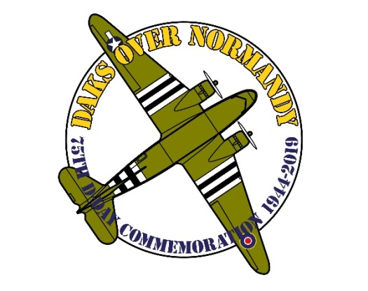
Daks over Normandy
Jump Registry Form
________________________________________________________________________________
This form is addressed to jumpers who wish to participate in the Daks over Normandy Jumps, that are organised on 4 and 5 June 2019 for the 75th D-Day commemoration.
_________________________________________________________________________________________
PERSONAL DATA
Name : Click here to enter text.
Surname : Click here to enter text.
Nationality : Click here to enter text.
Date of Birth : Click here to enter text.
Place of Birth : Click here to enter text.
E-Mail address : Click here to enter text.
Cell Phone : Click here to enter text.
Number of round canopy jumps to date : Click here to enter text.
Are you a member of a jump team? Which? : Click here to enter text.
I want my team members on the same aircraft Yes/No : Yes ☐ No ☐
JUMP INFO / QUALIFICATIONS
Military trained on round parachutes Yes/No? : Yes ☐ No ☐
If yes, when and where? : Click here to enter text.
Military qualifications as Jump master Yes/No? : Yes ☐ No ☐
If yes, when did you last Jump master? : Click here to enter text.
Civilian qualifications as Jump master or Instructor Yes/No? : Click here to enter text.
If yes, when did you last Jump master? : Click here to enter text.
I hold a civilian parachuting license? : Yes ☐ No ☐
Of which country? Click here to enter text.
REQUIREMENTS
In order to make these jumps there are a number of non-negotiable requirements.
At the time these jumps are to take place:
* you must have made at least 10 jumps with round steerable canopies.
* at least 1 of these must have been made in the 180 days preceding the event.
* you must be in possession of your own round parachute equipment and know how to pack it.
* you must be in possession of a medical certificate “fit for parachuting’, valid for 1 year.
* you must be in possession of a travel/medical insurance which covers high risk sports.
________________________________________________________________________________
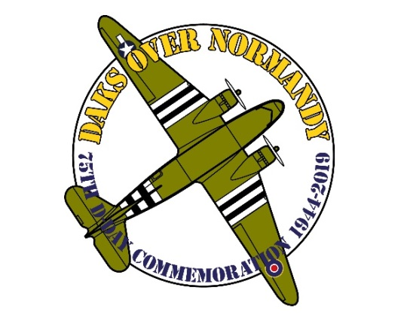
_______________________________________________________________________________
JUMPS
For the 75th D-Day commemoration Daks over Normandy offers two very special jumps :
1. Tuesday, June 4th – Afternoon – Practice Jump at Duxford Airfield UK
2. Wednesday, June 5th – Evening – Cross Channel Jump into Normandy, France
The jumps will all be made from Douglas DC-3/C-47/Li-2 Type aircraft.
EQUIPMENT
Your Paperwork will be inspected before the jumps.
All equipment has to be rigger inspected. (1 year for main canopy, 6 months for reserve canopy)
1. Jump equipment
Daks over Normandy does not have rental parachutes available.
2. Mass jumps & personal equipment
Non-steerable canopies are not allowed. With regards to personal equipment during the jumps, only M36 suspenders, Mae West, musette-bag + para rope and gas mask bag are allowed. Again due to regulations, weapons (either live or replica) are strictly prohibited. You ARE authorised to carry a jump (safety) knife.
3. Main canopies
Only steerable and non-modified main canopies are allowed.
4. Opening system
Only the direct-bag opening system is allowed with static-line and 5 foot extension.
5. Reserves
Only MIRPS (centre- or side pull) or modified T10R with MA1 kicker plate are allowed.
6. Material age & Date of Manufacture
No components of your equipment can be older than 25 years.
The DOM (Date Of Manufacture) must be after June 1994.
UNIFORMS AND PERSONAL EQUIPMENT
As this is the 75th D-Day commemoration we are putting an emphasis on having the correct uniforms.
Allowed are Allied World War 2 military airborne uniforms with correct boots and period correct helmets.
Fixed and D-bale helmets are NOT allowed. You are allowed to wear personal equipment such as suspenders, musette bags, etc. However except for jump (safety) knives, all weapons are strictly prohibited and so are leg bags and weapons containers.
_________________________________________________________________________________________________________________
_______________________________________________________________________________
Timeline
Your presence is expected at Duxford Airfield, United Kingdom not later than 3 June 2019 at 15.00 hours.
4 June 2019 Afternoon – Practice Jump
5 June 2019 Evening – Cross Channel Jump
More info will of course follow in due time.
PACKAGE
The complete package for this D-Day 75th commemoration consists of:
* Admission to Duxford Airfield from 3 to 5 June, including all museums & exhibitions.
* 2 nights’ accommodation, including breakfast.
* A BBQ and a running buffet in the evenings of 3 and 4 June.
* 4 June practice jump at Duxford Airfield and 5 June cross Channel Jump into Normandy, France.
The price of this full package is £ 625,00 per person.
NON PROFIT SET-UP
Daks over Normandy is set-up as a non-profit organization and there are ongoing efforts to obtain the necessary funding for the event. If we succeed in obtaining the complete budget, all registered jumpers will receive a partial or a full refund.
NOTICES!
This form must by fully filled-in and send to our e-mail address to register for these jumps. With the form you must also send with your form a clear copy of your passport (valid for June 2019). This is for customs purposes. Our E-mail address is: airborne@daksovernormandy.com
We will regard every fully filled-in form accompanied by a copy of your passport as you having signed the form and having agreed with the content of this form.
After receipt of your registration, you will receive an invoice from us in your e-mail. It contains all necessary payment information. The full amount has to be paid within 4 weeks after the date of the invoice.
Your registration will be valid only when the total payment is received.
________________________________________________________________________________
The Daks over Normandy team is looking forward to welcome you all for this 75th
commemoration of one of the most significant events in modern history. D-Day!
Notes!
Failure to meet the requirements on registration will exclude you from participation.
Failure to meet the requirements on arrival at Duxford will exclude you from participation and you will not receive a refund.
_______________________________________________________________________________

